# **Caremark.com – Quick Registration Enrollment Website**

|  |
| --- |
| **Scenario/Member** |

I would like to register.

Is there a way to manage my prescriptions without calling in?

Where can I see my orders?

|  |
| --- |
| **Process Demonstration – Video Walkthrough** |

Click [Registration Flow Video Demonstration](https://thesource.cvshealth.com/nuxeo/thesource/#!/view?docid=22bdbbe1-fb7a-4e8d-bf5c-c9aff4348b1d) to view a video walkthrough of overall steps outlined in this job aid.

|  |
| --- |
| **Quick Registration Reminders** |

Members of the following three (3) clients cannot be registered. Inform members that they need to use [Single Sign On](https://thesource.cvshealth.com/nuxeo/thesource/#!/view?docid=3e07129a-dc51-4946-860e-68cc06faf6f2) (SSO) from Client website.

* CareFirst
* Blue Shield of CA (BSC)
* Blue Cross Blue Shield Massachusetts

Registration is for members 18 and over unless the client has made an exception. Refer to [Underage Registration Client List](https://thesource.cvshealth.com/nuxeo/thesource/#!/view?docid=eb792f51-1f41-45dd-b0fc-e0de7ed06845).

|  |
| --- |
| **Quick Registration Process** |

1. Click **Caremark.com**.

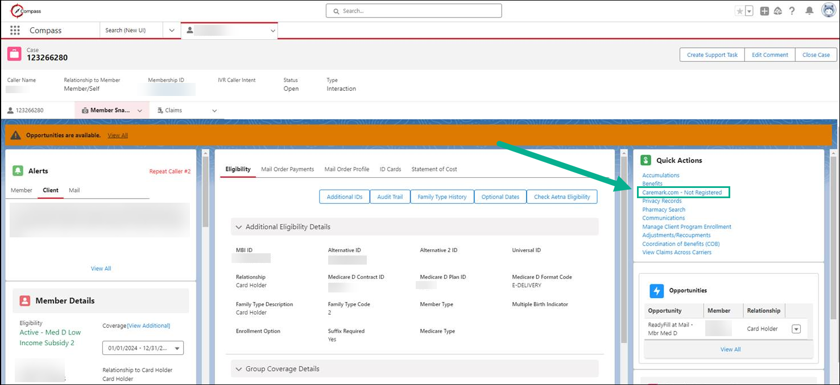

**Exceptions:**

* **Caremark.com – Registered:** Inform the member they are already registered, they just need to log in.

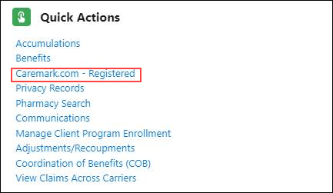

* **Caremark.com – Registration Unknown:** Review [troubleshooting](https://thesource.cvshealth.com/nuxeo/thesource/#!/view?docid=002cc829-ccea-4b1c-bd0c-33ef8ddfd6ba).

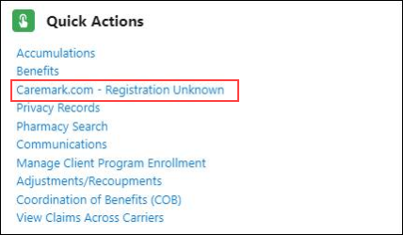

1. Follow Prompts and click **Send**.

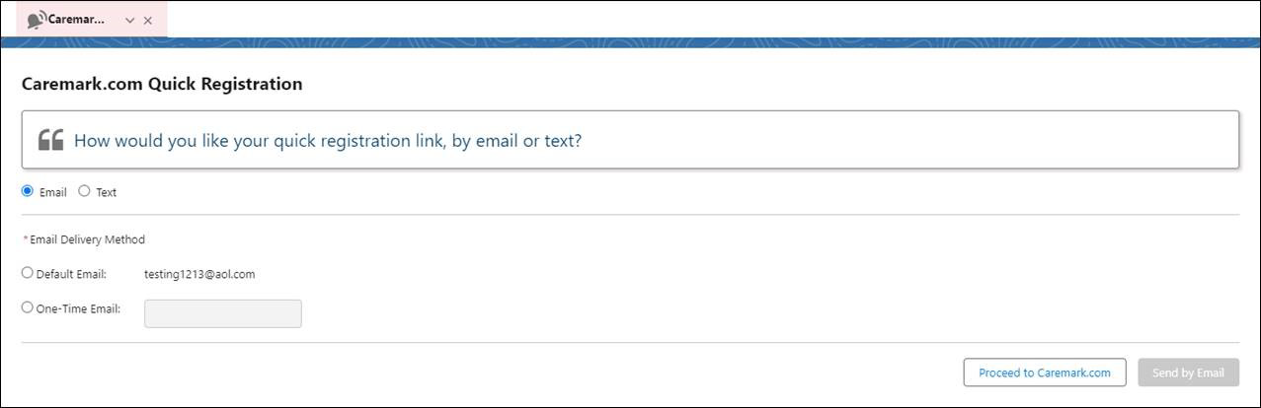

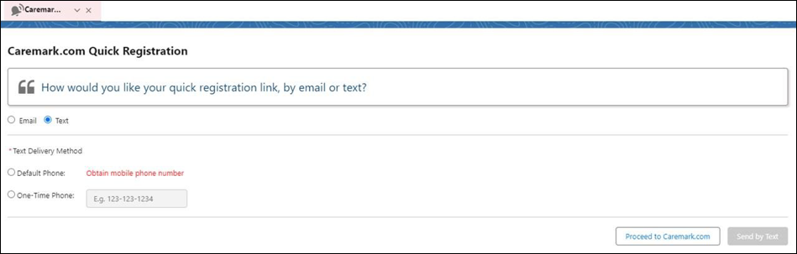

1. **Inform the member:**

* Email or text messages should arrive within 1 to 2 minutes
* Registration link will expire in 72 hours

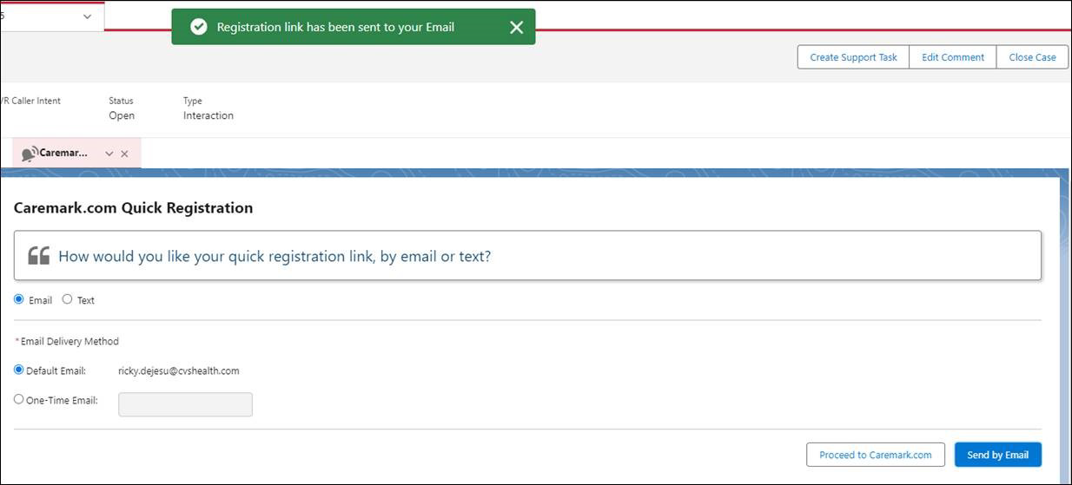

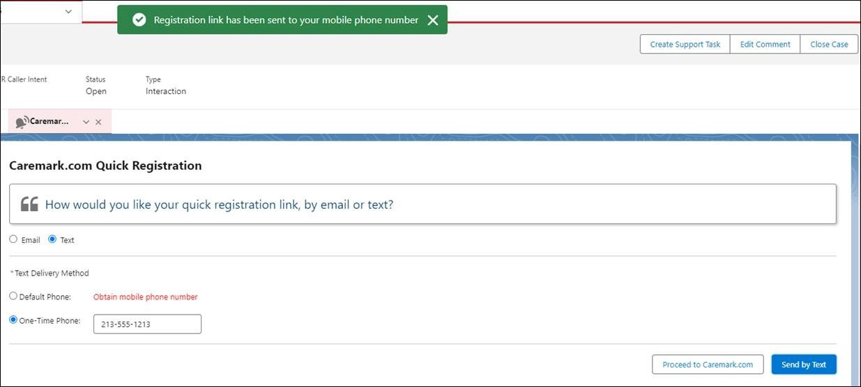

**Exception:**

* **Go to** [Standard Registration Sign Up](https://thesource.cvshealth.com/nuxeo/thesource/#!/view?docid=3d8135d2-1892-464a-aa80-61a2d1ae3146)

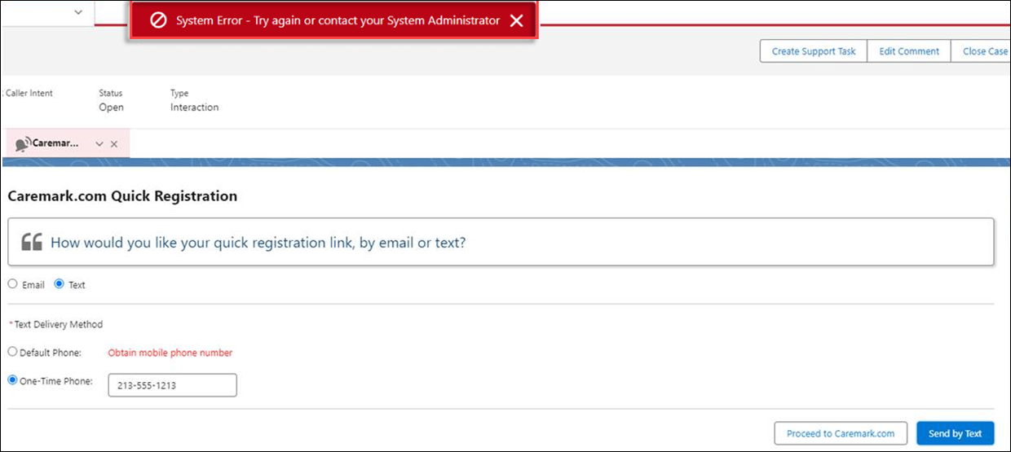

|  |
| --- |
| **Related Documents** |

[Caremark.com - Common Member Assistance Call Types Index](https://thesource.cvshealth.com/nuxeo/thesource/#!/view?docid=947b0b38-401d-4b18-a08e-60348558a9b9)

[Caremark.com – Troubleshoot Standard Registration Sign Up](https://thesource.cvshealth.com/nuxeo/thesource/#!/view?docid=002cc829-ccea-4b1c-bd0c-33ef8ddfd6ba)

**Full Details Document:**  [Quick Registration for Caremark.com](https://thesource.cvshealth.com/nuxeo/thesource/#!/view?docid=c90a32de-421f-42c2-8d5c-69ce36571418) or [Compass – Caremark.com Quick Registration](https://thesource.cvshealth.com/nuxeo/thesource/#!/view?docid=0b9a88e0-b8ac-472a-925b-dfc9e016614a)

Not To Be Reproduced Or Disclosed to Others Without Prior Written Approval

**ELECTRONIC DATA = OFFICIAL VERSION / PAPER COPY = INFORMATIONAL ONLY**